**Project Design Phase-I**

**Solution Architecture**

|  |  |
| --- | --- |
| Date | 19 September 2022 |
| Team ID | PNT2022TMID14838 |
| Project Name | Project – Personal assistant for Seniors who are self-reliant |
| Maximum Marks | 4 Marks |

**Solution Architecture Diagram:**

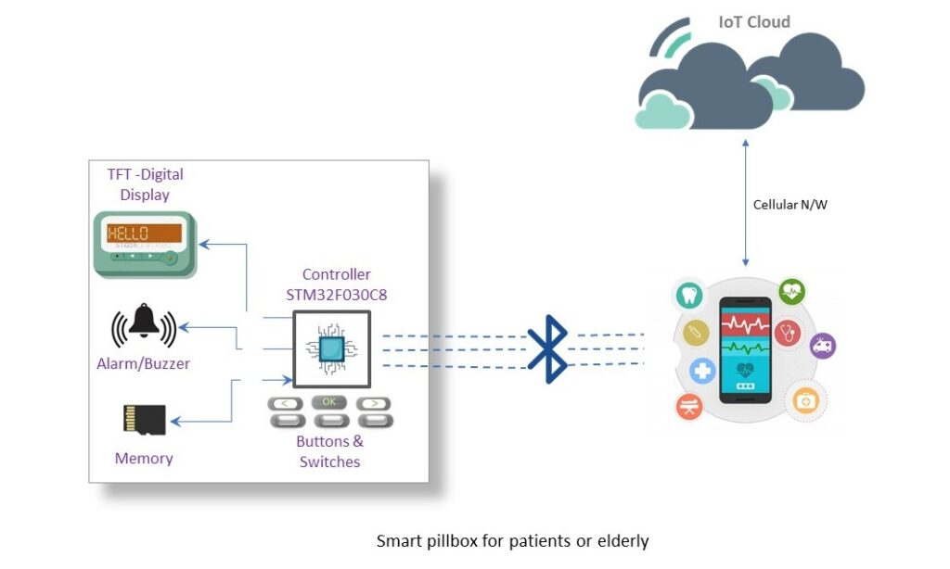

Figure 1: Architecture and data flow of the personal assistant sample application

This architecture shows the working of the system. A medicine reminder app that manages prescription schedules and alerts for reminding patients about the type and time of the medication according to the prescribed medicine schedule. Sometimes elderly people forget to take the medicine at the correct time. They also forget which medicine He / She should take at that particular time.And it is difficult for doctors/caretakers to monitor the patients around the clock. To avoid this problem, this medicine reminder system is developed.

**Methodologies :**

An app is built for the user (caretaker) which enables him to set the desired time and medicine. These details will be stored in the IBM Cloudant DB. if the medicine time arrives the web application will send the medicine name to the IoT Device through the IBM IoT platform. The device will receive the medicine name and notify the user with voice commands.

**Algorithm:**

**Step 1:**

**Future scope and Conclusion:**

The installation of an Internet of Things (IoT) device that provides a comprehensive solution for independent seniors. A novel idea is to put in place an automated system that will remind seniors with medical conditions to take their medications on time and will also keep track of their health problems. For elders, this idea suggests a Smart IoT personal assistant that can also help with remote monitoring.